2.6 I can check that my web pages meet needs using IT tools and making corrections as necessary

I started this document on my mobile and finished it on my laptop so I have two instances of code:

**Instance 1:**

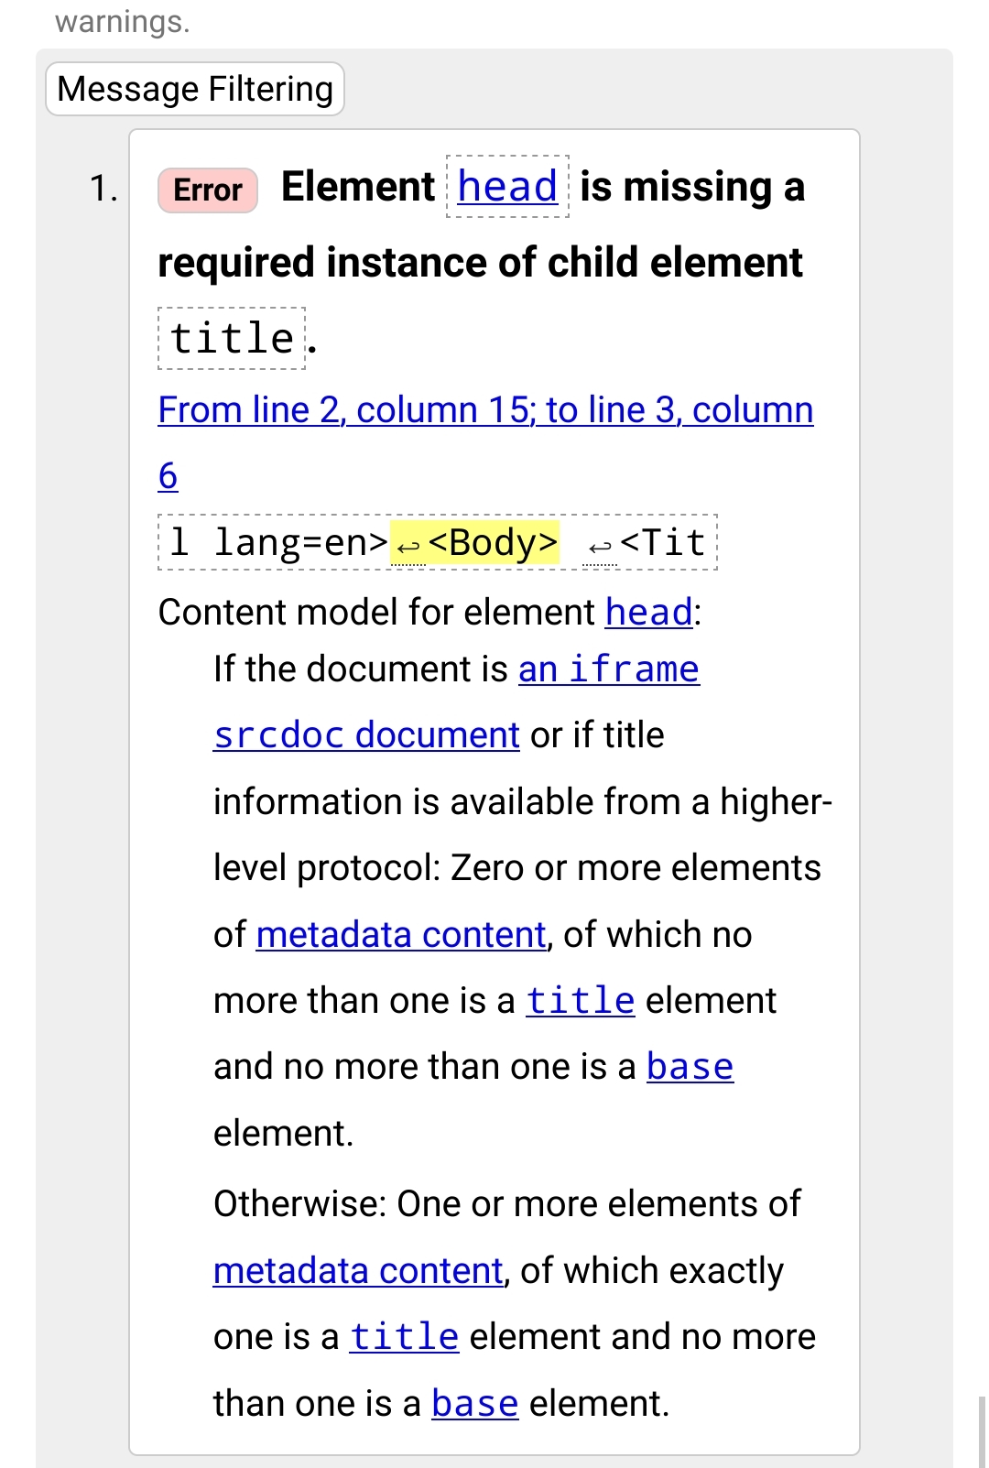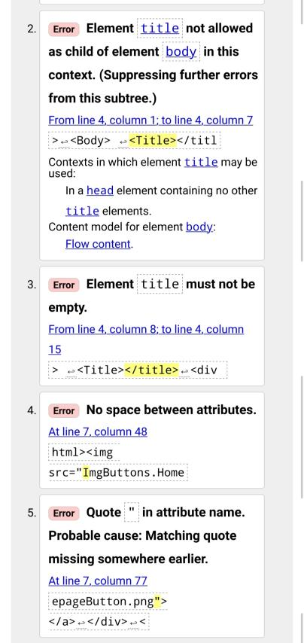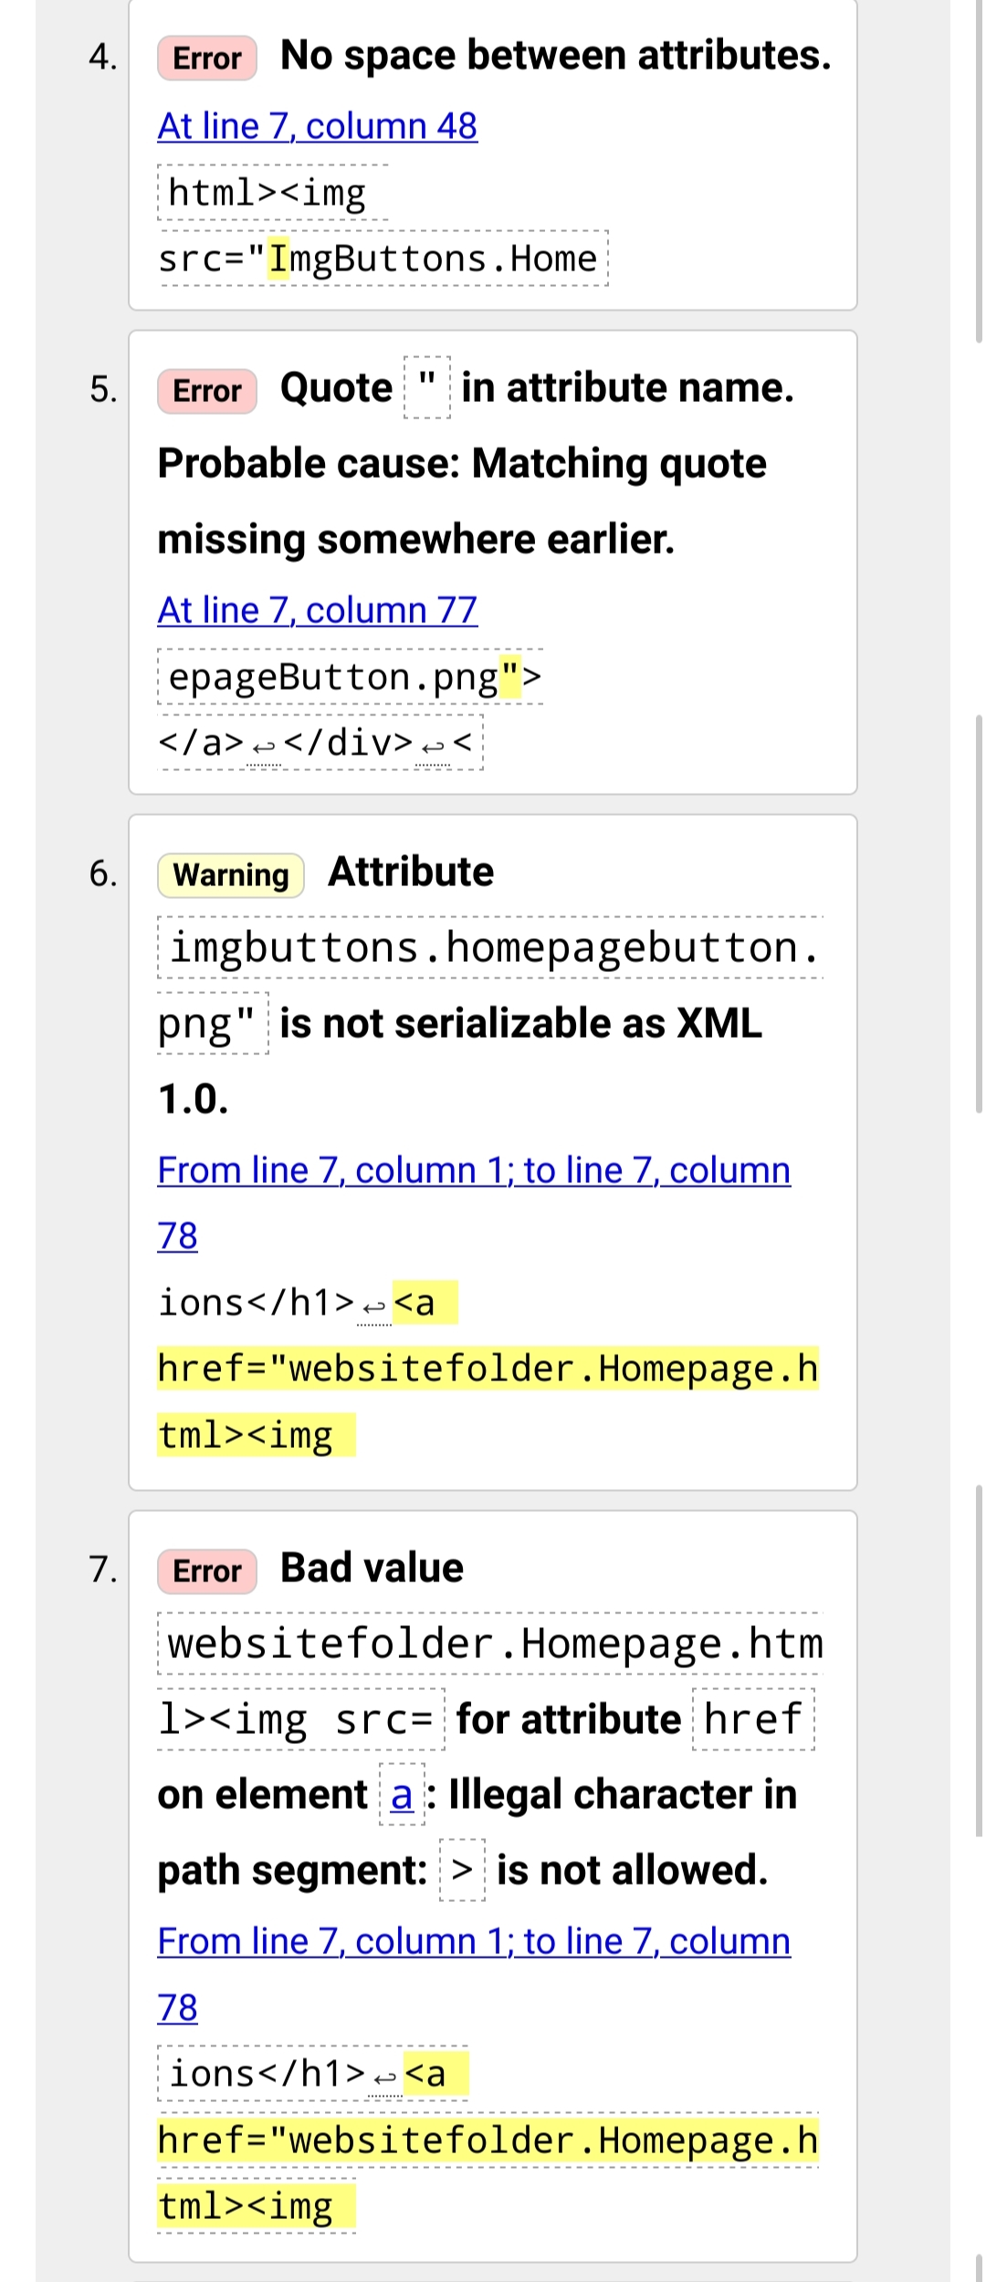

**Instance 2:**

**Warning**: Consider adding a lang attribute to the html start tag to declare the language of this document.

TYPE html>**↩<html>**↩<head>

**Error**: Element title must not be empty.

<title>**</title>**↩</head>

**Warning**: The document is not mappable to XML 1.0 due to two consecutive hyphens in a comment.

<body>↩ <!----**-**-Wraps whole p

**Error**: The center element is obsolete. [Use CSS instead](http://wiki.whatwg.org/wiki/Presentational_elements_and_attributes" \o "About using CSS instead of presentational elements and attributes.).

ge-->↩ **<center>**↩

**Error**: An img element must have an alt attribute, except under certain conditions. For details, consult [guidance on providing text alternatives for images](https://www.w3.org/WAI/tutorials/images/" \o "About providing text alternatives for images.).

**<img src="../images/original/Japan1.jpg"/>**↩

**Warning**: The document is not mappable to XML 1.0 due to two consecutive hyphens in a comment.

<!----**n**avigation-->↩

**Error**: Bad value ../images/button img/Home nav button2.jpg for attribute src on element [img](https://html.spec.whatwg.org/multipage/" \l "the-img-element): Illegal character in path segment: space is not allowed.

age.html">**<img src="../images/button img/Home nav button2.jpg" />**</a>↩

**Error**: An img element must have an alt attribute, except under certain conditions. For details, consult [guidance on providing text alternatives for images](https://www.w3.org/WAI/tutorials/images/" \o "About providing text alternatives for images.).

age.html">**<img src="../images/button img/Home nav button2.jpg" />**</a>↩

**Error**: Bad value ../images/button img/Page 2 nav button.jpg for attribute src on element [img](https://html.spec.whatwg.org/multipage/" \l "the-img-element): Illegal character in path segment: space is not allowed.

nto.html">**<img src="../images/button img/Page 2 nav button.jpg" />**</a>↩

**Error**: An img element must have an alt attribute, except under certain conditions. For details, consult [guidance on providing text alternatives for images](https://www.w3.org/WAI/tutorials/images/" \o "About providing text alternatives for images.).

nto.html">**<img src="../images/button img/Page 2 nav button.jpg" />**</a>↩

**Error**: Bad value ../images/button img/Page 3 nav button.jpg for attribute src on element [img](https://html.spec.whatwg.org/multipage/" \l "the-img-element): Illegal character in path segment: space is not allowed.

ubu.html">**<img src="../images/button img/Page 3 nav button.jpg" />**</a>↩

**Error**: An img element must have an alt attribute, except under certain conditions. For details, consult [guidance on providing text alternatives for images](https://www.w3.org/WAI/tutorials/images/" \o "About providing text alternatives for images.).

ubu.html">**<img src="../images/button img/Page 3 nav button.jpg" />**</a>↩

**Error**: Bad value ../images/button img/Page 4 nav button.jpg for attribute src on element [img](https://html.spec.whatwg.org/multipage/" \l "the-img-element): Illegal character in path segment: space is not allowed.

shu.html">**<img src="../images/button img/Page 4 nav button.jpg" />**</a>↩

**Error**: An img element must have an alt attribute, except under certain conditions. For details, consult [guidance on providing text alternatives for images](https://www.w3.org/WAI/tutorials/images/" \o "About providing text alternatives for images.).

shu.html">**<img src="../images/button img/Page 4 nav button.jpg" />**</a>↩

**Error**: Bad value ../images/button img/Page 5 nav button.jpg for attribute src on element [img](https://html.spec.whatwg.org/multipage/" \l "the-img-element): Illegal character in path segment: space is not allowed.

uku.html">**<img src="../images/button img/Page 5 nav button.jpg" />**</a>↩

**Error**: An img element must have an alt attribute, except under certain conditions. For details, consult [guidance on providing text alternatives for images](https://www.w3.org/WAI/tutorials/images/" \o "About providing text alternatives for images.).

uku.html">**<img src="../images/button img/Page 5 nav button.jpg" />**</a>↩

**Error**: The frameborder attribute on the iframe element is obsolete. [Use CSS instead](http://wiki.whatwg.org/wiki/Presentational_elements_and_attributes" \o "About using CSS instead of presentational elements and attributes.).

**<iframe width="560" height="315" src="https://www.youtube.com/embed/aW_sw77sqvE" title="YouTube video player" ↩ frameborder="0" allow="accelerometer; autoplay; clipboard-write; encrypted-media; ↩ gyroscope; picture-in-picture" allowfullscreen>**</ifra

**Warning**: The document is not mappable to XML 1.0 due to two consecutive hyphens in a comment.

<!----**-**Footer--> ↩

For instance 1 I just changed the body and html to correct any issues and learned the proper DOC format.

For Instance 2 I reviewed my document and changed it accordingly as suggested by the validator. I did keep in <center> and other known obsolete tags as they will still work but this validator just suggests that I do not use them. I have also added the alt to all my pictures in my code as this is an accessibility issue. Lang=en is also important.

<!DOCTYPE html>

<html lang="en">

<head>

<link href="../scripts/index.css" rel="stylesheet" />

<meta charset="utf-8" />

<title></title>

</head>

<body>

<!------Wraps whole page-->

<center>

<div class="Wrapper">

<img src="../images/original/Japan1.jpg"/>

<h1 style="color:#ffd800">The Japanese Regions</h1>

<!----navigation-->

<div class="Nav">

<a href="Homepage.html"><img src="../images/button img/Home nav button2.jpg" alt="home button" /></a>

<a href="Kanto.html"><img src="../images/button img/Page 2 nav button.jpg" alt="button to kanto page" /></a>

<a href="Chubu.html"><img src="../images/button img/Page 3 nav button.jpg" alt="button to chubu page"/></a>

<a href="Kyushu.html"><img src="../images/button img/Page 4 nav button.jpg" alt="button to kyushu page" /></a>

<a href="Tohuku.html"><img src="../images/button img/Page 5 nav button.jpg" alt="button to tohuku page"/></a>

</div>

<!---map test-->

<div class="map"></div>

<!-----Footer-->

<div class="Footer"><p>©Daniel Powis</p></div>

</div>

</center>

</body>

</html>

**CSS**: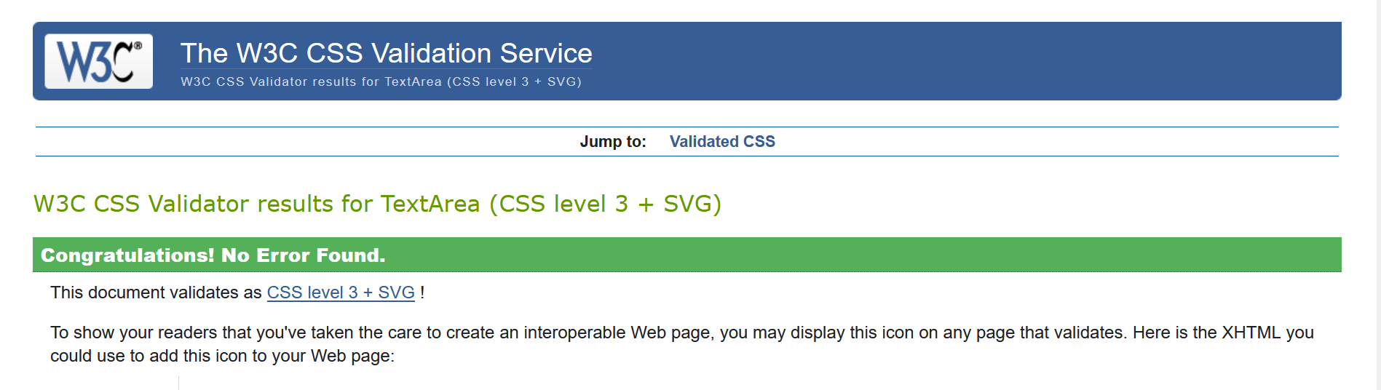

[The above pictures show that I had no errors for my CSS code]